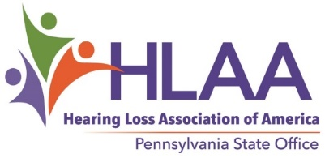
DIANA BENDER HLAA NATIONAL CONVENTION SCHOLARSHIP
The Hearing Loss Association of America Pennsylvania State Office (HLAA-PA) will offer a scholarship to assist a Pennsylvania resident who is a member of the Hearing Loss Association of America to attend the 2022 HLAA convention. The scholarship will be available for a deserving person who is currently involved with hearing loss issues. The HLAA-PA Advisory Council’s Scholarship Committee will select the qualifying applicant.
When and where is the 2022 HLAA convention? The convention will be held June 23-25 at the JW Marriott Tampa Water Street in Tampa, Florida.
Who is eligible as a scholarship candidate? Any Pennsylvania resident with hearing loss, regardless of age, is eligible as long as he or she meets the following qualifications: The applicant must be a current HLAA member, must have demonstrated an interest in being actively involved with hearing loss issues, and must indicate that a scholarship would enable attending the convention. Preference will be given to those who have never attended an HLAA convention.
Scholarship amount: The recipient will be awarded $500 (to be applied to transportation, lodging, and meals), plus the cost of registration for the full-activity convention package (includes banquet). Any cost exceeding $500 will be the recipient’s responsibility. The recipient must attend the convention or return the award.
Submission date: Email information to Mitchell Bilker, HLAA-PA Scholarship Committee Chair, at scholarship@hlaa-pa.org or mail this form to HLAA-PA National Scholarship, 821 Rosehill Drive, King of Prussia, PA 19406 (email preferred).
Deadline for receipt is March 1, 2022.
_ _ _ _ _ _ _ _ _ _ _ _ _ _ _ _ _ _ _ _ _ _ _ _ _ _ _ _ _ _ _ _ _ _ _ _ _ _ _ _ _ _ _ _ _ _ _ _ _ _ _ _ _ _ _ _
Diana Bender HLAA National Convention Scholarship Application Form for 2022 Convention
Name: __________________________________________
Address: ______________________________________ City:_________________________ State: PA
Telephone: __________________ Email: __________________________________________________
What is the expiration date of your HLAA membership? (See your Hearing Life label.) ________________ Have you ever attended an HLAA convention? yes ____ no_____
Why should you be selected? Use a second page if necessary.

