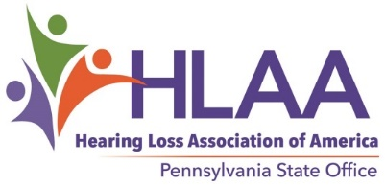
DIANA BENDER HLAA NATIONAL CONVENTION SCHOLARSHIP
The Hearing Loss Association of America Pennsylvania State Office (HLAA-PA) will offer a scholarship to assist a Pennsylvania resident who is a member of the Hearing Loss Association of America to attend the 2024 HLAA convention. The scholarship will be available for a deserving person who is currently involved with hearing loss issues. The HLAA-PA Advisory Council’s Scholarship Committee will select the qualifying applicant.
When and where is the 2024 HLAA convention? The convention will be held June 26–29, 2024 at the Sheraton Grand Resort at Wild Horse Pass, Phoenix, AZ.
Who is eligible as a scholarship candidate? Any Pennsylvania resident with hearing loss, regardless of age, is eligible as long as he or she meets the following qualifications: The applicant must be a current HLAA member, must have demonstrated an interest in being actively involved with hearing loss issues, and must indicate that a scholarship would enable attending the convention. Preference will be given to those who have never attended an HLAA convention.
Scholarship amount: The recipient will be awarded $500 (to be applied to transportation, lodging, and meals), plus the cost of registration for the full-activity convention package (includes banquet). Any cost exceeding $500 will be the recipient’s responsibility. The recipient must attend the convention or return the award.
Submission date: Email information to Mitchell Bilker, HLAA-PA Scholarship Committee Chair, at scholarship@hlaa-pa.org or mail this form to HLAA-PA National Scholarship, 821 Rosehill Drive, King of Prussia, PA 19406 (email preferred).
Deadline for receipt is May 1, 2024.
_ _ _ _ _ _ _ _ _ _ _ _ _ _ _ _ _ _ _ _ _ _ _ _ _ _ _ _ _ _ _ _ _ _ _ _ _ _ _ _ _ _ _ _ _ _ _ _ _ _ _ _ _ _ _ _
Diana Bender HLAA National Convention Scholarship Application Form for 2024 Convention
Name: __________________________________________
Address: ______________________________________ City:_________________________ State: PA
Telephone: __________________ Email: __________________________________________________
What is the expiration date of your HLAA membership? (See your Hearing Life label.) ________________ Have you ever attended an HLAA convention? yes ____ no_____
Why should you be selected? Use a second page if necessary.

