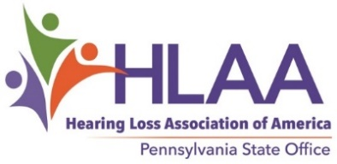
MARCIA FINISDORE AWARD FOR ADVOCACY
The Marcia Finisdore Award for Advocacy was established by HLAA-PA in 2004 to honor our first state director. Marcia was a tireless advocate for people with hearing loss throughout her life. This award is presented to an individual in recognition of excellence in improving communication access for hard of hearing people. The criteria for selection are:
• A positive vision for the hard of hearing community and a continuing commitment to leadership.
• A demonstrated record of advocacy work for the rights and needs of hard of hearing people in the Commonwealth of Pennsylvania.
Nominations must include a written statement about the nominee explaining why this individual deserves the award and be sent to Diana Bender, Bender@hlaa-pa.org or 101 Oakwood Lane, Phoenixville, PA 19460 (email preferred).
Deadline for receipt is Mayl 1, 2024.
_ _ _ _ _ _ _ _ _ _ _ _ _ _ _ _ _ _ _ _ _ _ _ _ _ _ _ _ _ _ _ _ _ _ _ _ _ _ _ _ _ _ _ _ _ _ _ _ _ _ _ _ _ _ _ _
Marcia Finisdore Award for Advocacy 2024 Nomination Form
Person being nominated: __________________________________________
Address: ______________________________________ City:_________________________ State: PA
Telephone: __________________ Email: __________________________________________________
:
Your name: __________________________________________
Address: ______________________________________ City:_________________________ State: PA
Telephone: __________________ Email: __________________________________________________

Why should the nominee receive this award? Use a second page if necessary.

