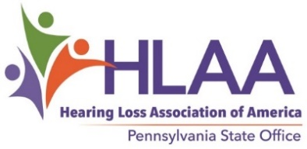
JOE MEYER MEMORIAL GRANT
The Joe Meyer Memorial Grant was established by HLAA-PA to assist Pennsylvania residents with hearing loss for one or more of the following purposes:
- To purchase hearing assistive technology, including hearing aids
- To cover expenses for cochlear implant surgery
- To participate in educational programs on coping with hearing loss for personal benefit and/or to help others
- To attend a college or technical institute
Two grants will be available for 2022. The HLAA-PA Advisory Council’s Joe Meyer Memorial Grant Committee will select the qualifying applicants.
Applicants may be of any age and must meet the following requirements:
- Be a Pennsylvania resident
- Have a documented hearing loss (provide documentation)
- Use residual hearing (can utilize hearing aids and/or cochlear implants) to communicate
- Indicate how the funds will be spent and provide a receipt for the purchase or evidence of college/technical institute enrollment
Grant amount: A recipient will be awarded up to $500.
Applications may be emailed or mailed (email preferred if possible) to Carolyn Meyer, Joe Meyer Memorial Grant Chair, at Meyer@hlaa-pa.org or 1250 Greenwood Ave., Apt. 807, Jenkintown, PA 19046.
Deadline for receipt is March 1, 2022.
_ _ _ _ _ _ _ _ _ _ _ _ _ _ _ _ _ _ _ _ _ _ _ _ _ _ _ _ _ _ _ _ _ _ _ _ _ _ _ _ _ _ _ _ _ _ _ _ _ _ _ _ _ _ _ _
Joe Meyer Memorial Grant 2022 Application Form
Name: __________________________________________
Address: ______________________________________ City:_________________________ State: PA
Telephone: __________________ Email: __________________________________________________
Why should you be selected? Use a second page if necessary.

